Module 4
Use inbuilt functions of Max,min and avg amount from the orders table
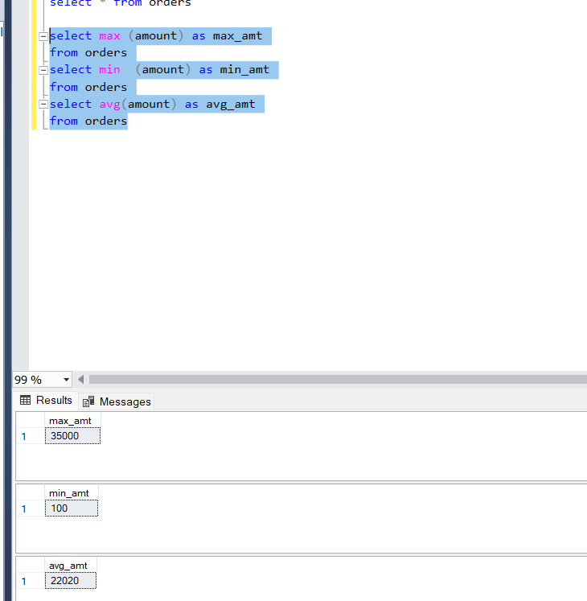

Module 4
Use the case statement to check if 100 is smaller than 200, greater than 200 or equal to 200 and print the corresponding value

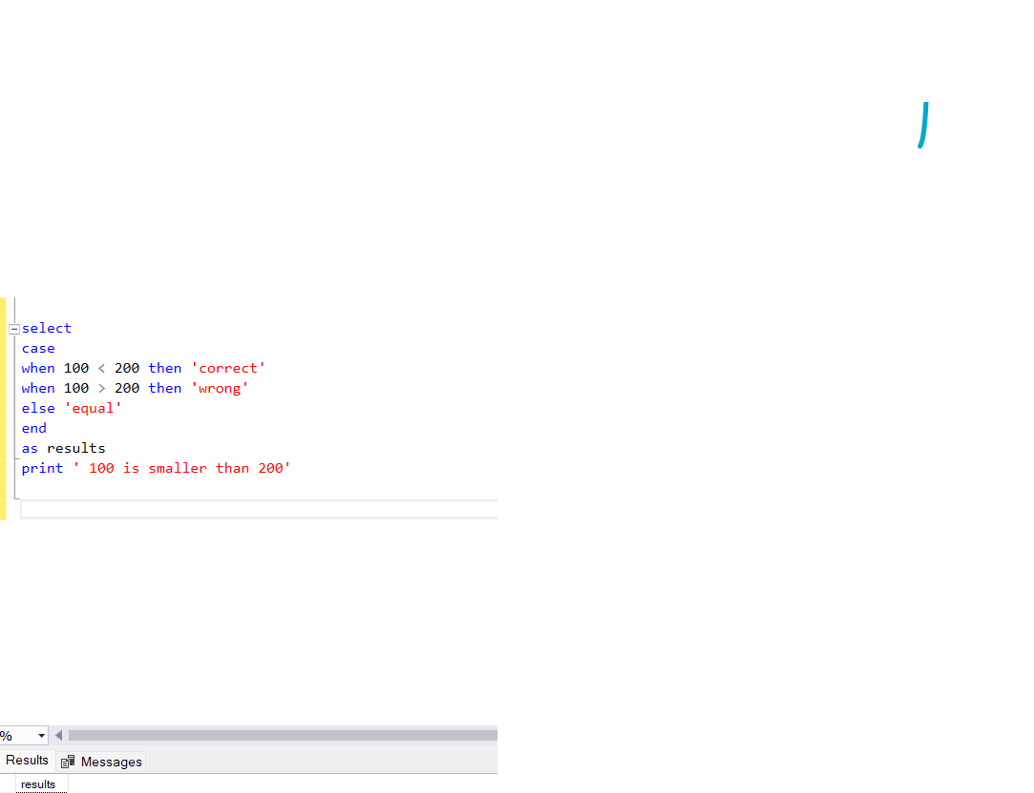

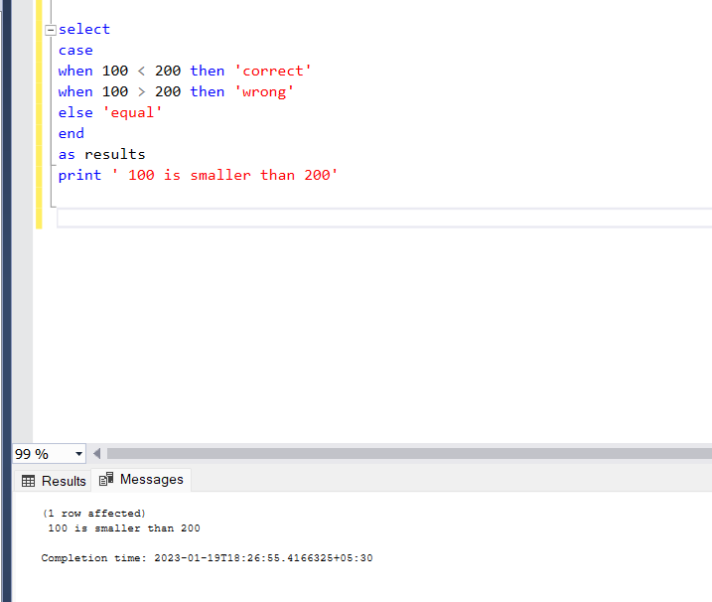

Module 4
Create a user defined function which will multiply with 10
